|  |
| --- |
| South Africa Livelihood Zone Profile  59202 – Northern Open Access Cattle and Dry Land Crops (*ZANOC*) |
| Zone Description |

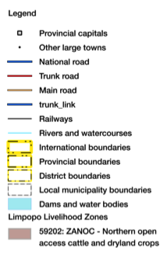This zone is located on the lowveld and middleveld plains in the north-west of Limpopo province with two small areas south-west and north of the Soutpansberg in Vhembe district.

Figure 1: Map of the livelihood zone

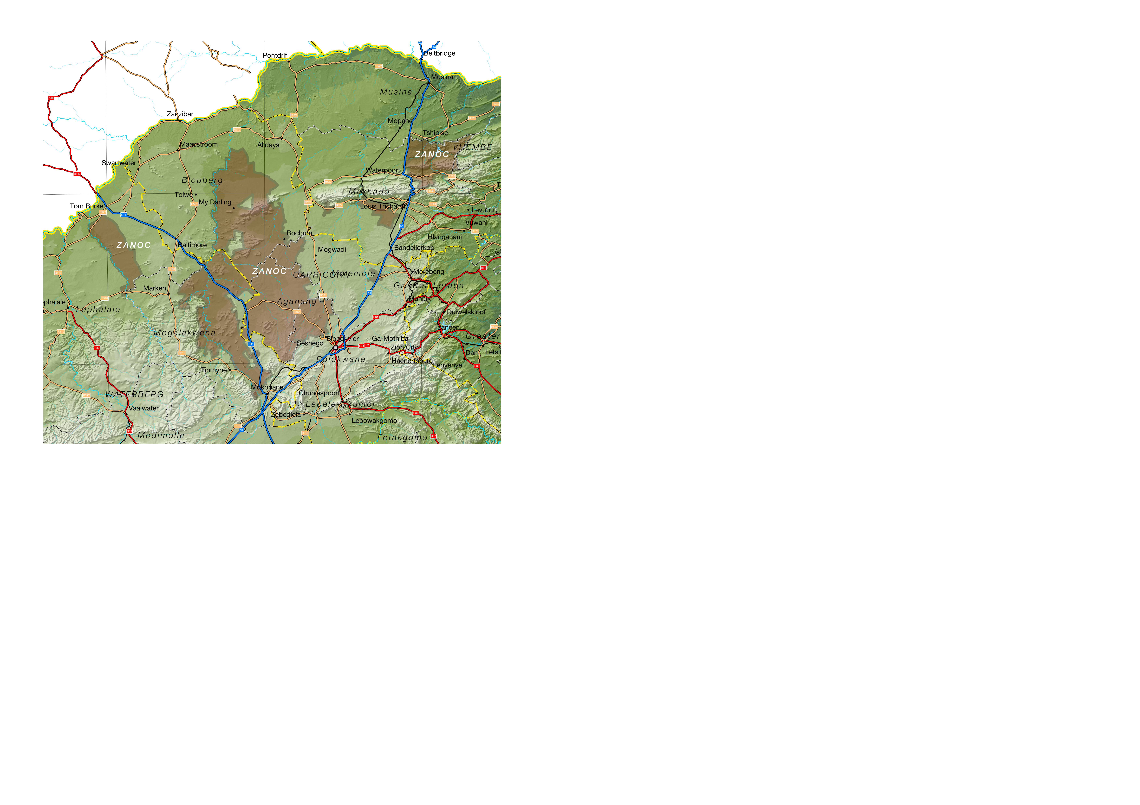Projection: Albers Equal Area with Standard Parallels at 22.67 S and 24.88 S, Longitude of Centre at 29.29 E.

Sources of data: Open Street Map, Highways (<http://wiki.openstreetmap.org/wiki/Planet.osm>) for the road lines, Shuttle Radar Topography Mission (SRTM) 3 version 2.1 (<http://www2.jpl.nasa.gov/srtm/>) for the elevation and relief shading and Agricultural Geo-referenced Information System (AGIS) (<http://www.agis.agric.za/agisweb/agis.html>) for places, boundaries and rivers.

The rainfall (the long term average annual precipitation is 200 to 400 mm in the north and just over 400 mm in the south-west) is barely adequate for dry land crop farming and the soils are poor. Almost all of the zone is 'moderate to severe' in water availability, the remainder being 'severe'. The savannah vegetation is well suited to cattle and these are important for livelihoods. Apart from cattle, households depend on petty trading, remittances and grants.

Table I - Census 2011 population breakdown of districts and municipalities covered by the livelihood zone

|  |  |  |  |  |
| --- | --- | --- | --- | --- |
| **Province** | **District** | **Municipality** | **Pop. Est. in ZANOC** | **Percent of total** |
| Limpopo | Capricorn | Aganang | 129,795 | 98.97% |
| Blouberg | 133,965 | 82.38% |
| Molemole | 62,067 | 57.28% |
| Polokwane | 122,238 | 19.44% |
| Vhembe | Makhado | 133,605 | 26.05% |
| Thulamela | 264 | 0.04% |
| Waterberg | Bela-Bela | 2,781 | 4.18% |
| Lephalale | 50,154 | 43.32% |
| Mogalakwena | 183,396 | 59.62% |
| **Provincial Total** |  |  | **818,265** | **15.15%** |

Source: Statistics South Africa, Census 2011 small area population data

Figure 2: Livelihood zone location



**Figure 1** is a map of the zone and **Figure 2** shows its location. The N11 is the main trunk route through the zone, although the N1, the R521 and the R518 skirt large sections. The R567, R523 and R522 provide important access to the northern areas. Polokwane serves as the main administrative and business centre to people in the zone, although Louis Trichardt is an important centre up north.

The livelihood zone has been given an alphabetic code (or abbreviation) of 'ZANOC' and a numeric code of 59202. These codes distinguish the zone both nationally and internationally, as well as allowing zone name changes and updates if desired (the code should always remain the same).

Figure 3: Gender and age breakdown of the zone population

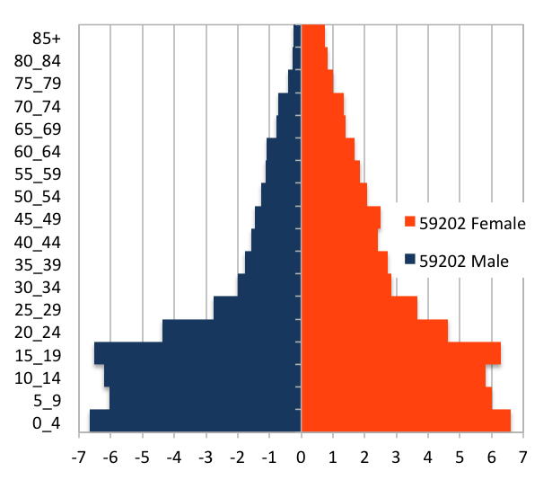 Source: Statistics South Africa, Census 2011 small areas and population database

As **Figure 1** shows, the livelihood zone spans nine municipalities in three districts. There are also areas in each municipality (some quite small, for example, in Aganang) that are *not* part of the zone, however. The total population in the zone is 818,265 (from the Census 2011) and this is 15,15% of the provincial total. The breakdown for each municipality is given in **Table I**.

The age and gender pyramid for the whole zone is given in **Figure 3**. It is important to note the low percentages of adult men as well as the high proportion of children (younger than 20). This unbalanced gender and dependency ratio is a consequence of apartheid, as most of the zone was a part of the former *bantustans*, supplying labour to urban, industrial and mining areas. The persistence of this pattern leads to shortages in the zone of human capital, which has impacts on productivity.

|  |
| --- |
| Seasonal Calendar |

Since this is a rural livelihood zone and rural life is determined by agricultural seasons, the information is organised by *consumption year*, which begins with the start of the main dry harvest and runs through to just before the next year's main dry harvest. In this zone, the main dry harvest begins in February, so the consumption year begins that month and runs up until the end of the following January. The livelihood strategies presented in this document apply to a particular year, one that is neither very good nor bad but is 'typical', or occurs frequently. This is called the *reference year* and the year chosen by participants was 2013-2014, or February 2013 to January 2014.

Figure 4: Seasonal calendar

|  |  |  |  |  |  |  |  |  |  |  |  |  |
| --- | --- | --- | --- | --- | --- | --- | --- | --- | --- | --- | --- | --- |
| **Activity** | Feb | Mar | Apr | May | Jun | Jul | Aug | Sep | Oct | Nov | Dec | Jan |
| Dry harvest & threshing |  |  |  |  |  |  |  |  |  |  |  |  |
| Land preparation |  |  |  |  |  |  |  |  |  |  |  |  |
| Ploughing & planting & weeding |  |  |  |  |  |  |  |  |  |  |  |  |
| Green harvest |  |  |  |  |  |  |  |  |  |  |  |  |
| Casual labour (agricultural) |  |  |  |  |  |  |  |  |  |  |  |  |
| Casual Labour (domestic work, herding & public works) |  |  |  |  |  |  |  |  |  |  |  |  |
| Wood collection |  |  |  |  |  |  |  |  |  |  |  |  |
| Marula brewing |  |  |  |  |  |  |  |  |  |  |  |  |

The crop farming period from September to January is the busiest with land preparation, ploughing, plating and weeding all taking place and agricultural casual labour opportunities increasing. Green crops are consumed in January at the end of the consumption year. This continues through the dry harvest period from February to May. Domestic work, herding and wood collection are not as seasonal, while Marula brewing takes place from February to April.

|  |
| --- |
| Wealth Breakdown |

Wealth in this livelihood zone is determined primarily by three factors:

1. Employment, a product education and good social connections;
2. Ownership of a business, such as a spaza shop or bakkie, taxi; and
3. 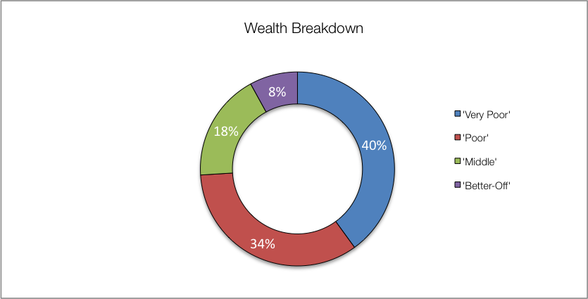Livestock, especially cattle.

Figure 5: Wealth breakdown in the northern open access cattle and dry land crops livelihood zone

|  |  |  |  |  |  |
| --- | --- | --- | --- | --- | --- |
| Category | Item | Wealth Group (typical value in brackets) | | | |
| 'Very poor' | 'Poor' | 'Middle' | 'Better off' |
| Hh Size |  | 3-10 (5) | 5-8 (6) | 5-8 (6) | 4-6 (5) |
| Land (Ha) | Owned | 0-2 (1) | 1-2 (1½) | 1-2 (1½) | 1-3 (2) |
| Cultivated | 0-2 (1) | 0-2 (1) | 1-2 (1½) | 1-2 (1½) |
| Livestock (head) | Cattle | 0 | 0-4 (1) | 5-14 (9) | 15-20 (18) |
| Goats | 0-3 (0) | 0-4 (2) | 6-12 (9) | 10-45 (18) |
| Income | Main | Grants | Grants | Formal employ | Formal employ |
| Annual (R) | 29,000 | 43,400 | 136,500 | 340,700 |

*Source: Survey output, 2015*

The wealthiest households, described as the 'better off', are those with permanent work and a salary of R9,000 to R30,000 a month. Households that have lower-paying or less permanent work, which on average over the year is R4,000 to R9,000 per month, are referred to as the 'middle'. Those who depend primarily on grants are described as the 'poor' and 'very poor'; collectively, they are almost three-quarters of households. The 'very poor' and 'poor' supplement their grant income from casual labour and other sources.

Wealthier households do cultivate somewhat larger farms (about 50% more by area) but differences are not substantial. As households begin with the same size stands, land ownership is only slightly skewed.

This zone is distinguished by the larger herds of small stock, especially goats, than elsewhere. This follows from the drier climate and bushier environment that is better suited to these animals.

Key informants in the villages tended to estimate larger household sizes, so field teams recorded values in excess to those reported in other surveys, especially the census. Except for single-people, the most frequent household size in this zone is four, while the greatest number of people reside in a household of five. The reported typical household size of 5-6 people, which is used in ensuing sources of food and income—these can be scaled to the appropriate household size from the census.

|  |
| --- |
| Sources of Food |

Purchases are the largest source of people's food, contributing 85% to more than 100% of minimum food energy needs. The contribution from staple food purchases *decrease* steadily as households get wealthier. Conversely, the contribution from non-staple food purchases *increases* with increasing wealth. Most households and all wealth groups also consume food from their own crop production, although this is hardly significant for the 'very poor', who lack the labour and capital to produce any significant quantities of their own food. The 'better off' and 'middle' have the highest contribution to their food energy from both staple and non-staple crops, at about 50% to 55% of their minimum needs.

Figure 6: Sources of food (expressed as percentage of minimum average food energy needs) for each wealth group

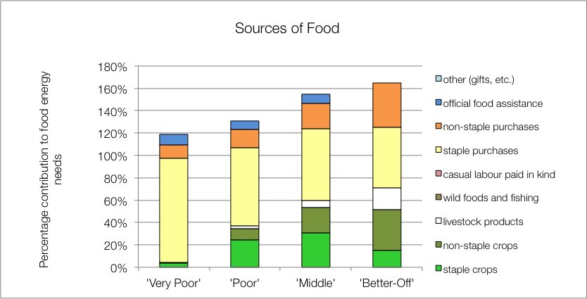

Only the 'middle' and 'better off' households obtain substantial food from their livestock; this is usually from cow's milk and occasional slaughter for meat (the 'poor' obtain a small contribution from the meat of an occasional slaughter). Dairy production in this zone is not commensurate with herd sizes and livestock ownership. In general, a fraction of lactating cows (about 1:3 to 1:6) are actually milked for consumption.

The poorest households' children receive additional food from school lunches, which is their official food assistance. Wealthier households tend to send their children to fee-paying schools that do not offer meals. All households may collect wild foods for consumption (e.g. mopane worm or marula fruit) but the quantities involved do not merit a significant contribution to food energy (the worms may be a significant protein source).

|  |
| --- |
| Sources of Cash Income |

Cash incomes vary considerably across wealth groups, with the 'better off' earning R340,700 per annum, almost twelve times as much as the 'very poor', who earn R29,000 per annum. **Figure 7** shows this distribution—it must be noted that the bars in the figure are not quartiles, they represent wealth groups and wealth groups are *not* distributed evenly (see **Wealth Breakdown**, above).

Figure 7: Sources of annual cash income by wealth group

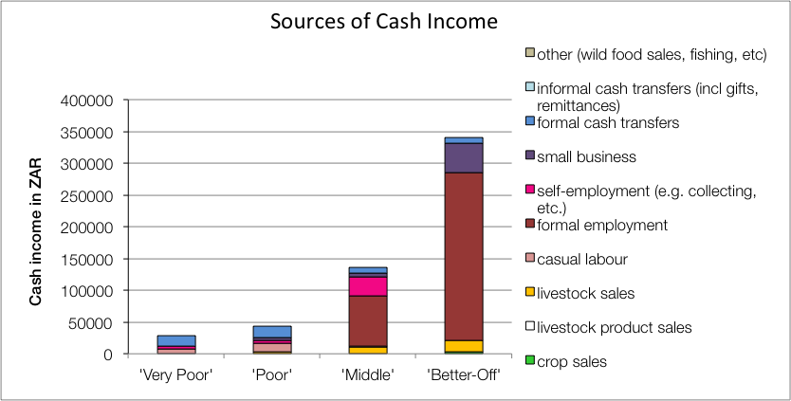

The main sources of cash incomes in the zone are: formal employment—for the 'middle' and 'better off'—and cash grants—for the 'poor' and 'very poor'. This is in keeping with most surveys ask for the main livelihood source.

Figure 8: Sources of annual cash income as a percentage of total, by wealth group

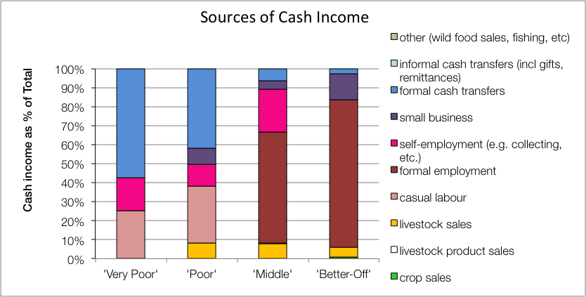

However, the point of this enquiry was to gain understanding of how *all* livelihood sources come together to make up an income. This is important because it enables practitioners to link a hazard (such as a price change) to an income and it enables other users to see potential areas of intervention. By dividing the value of each source by the total income, we can see these proportions and this is presented in the graph in **Figure 8**.

For the 'very poor' and 'poor', grants make up 57% and 42% of total cash income, respectively; the remainder coming from casual labour (mostly domestic work, agricultural piece work, construction jobs) and self-employment (collecting natural products for sale, weaving, making bricks, etc.). The 'poor', 'middle' and 'better off' earn some of their cash (around 8%) from animal sales and also from petty trading or a small business (4% to 14%).

The 'middle' and 'better off' gain their wealth from a formal wage or salary for the better part of their income. Some 'middle' households may have a member that works seasonally on the commercial farms but earnings typically amount to almost R79,000 per annum, while the 'better off' earn around R264,000 per annum. 'Middle' and 'better off' households also gain a little cash from grants (for example, pensions and fostering are not means-tested and the probability of a household having a pensioner in it is about one in two—see the population pyramid under **Zone Description**).

It can be seen that the earnings from livestock products are nil, which is lost productivity. The numbers of cows that are actually milked compared with those likely to be lactating is low and this is due to a number of factors: lack of economic incentives for milking, lack of time by the cattle-owners (because they are full-time employed) and minimal herd management.

|  |
| --- |
| Hazards, Vulnerabilities and Response Strategies |

Since households are dependent on markets for most of their food, they are therefore most vulnerable to market shocks. These 'market shocks' may consist of: escalating food prices, eroded grants (for example, when they are not adjusted to match consumer inflation) and job losses.

Droughts are frequent and also have an impact on food production by reducing crops. However, unless food prices also rise simultaneously, households will manage crop losses by prioritising more cash to their food purchases. A severe drought can badly affect animal condition and production but the current low productivity means that it would only have an impact on 'better off' households' asset bases.

Additional response strategies households may engage in under stress are: switching expenditure, seeking more casual work (usually outside of the village) or selling off assets or belongings.

|  |
| --- |
| Household Hunger Score |

The majority of the households (76%) experience no to little hunger and two per cent of households had severe hunger in this livelihood zone. Only 22 per cent of the households reported a moderate hunger situation (**Table II**)

Table II - Household Hunger scale indicator

|  |  |  |  |  |  |
| --- | --- | --- | --- | --- | --- |
| No to Little Hunger | | Moderate Hunger | | Severe Hunger | |
| Count | Percent | Count | Percent | Count | Percent |
| 203 | 76 | 59 | 22 | 4 | 2 |

Source: Survey Output 2015

|  |
| --- |
| Dietary Diversity and Food Consumption Score |

The largest number – 42 percent of sampled households – have a medium dietary diversity score indicating that they consumed about four to five food groups during the day before the survey. 35 Percent of households have highest dietary diversity (consuming at least six food groups) and there is a high percentage of households with the lowest dietary diversity (23%) indicating that they consume three or fewer food groups.

On the food consumption score, the majority of households – 59 percent – were consuming adequately diversified diets. Eight percent of the households were within borderline consumption and about 33 percent of the households are consuming an unacceptable diversity of foods.

Figure 10: Food consumption scores

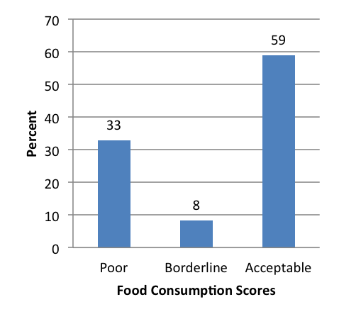

Figure 9: Dietary Diversity Scores

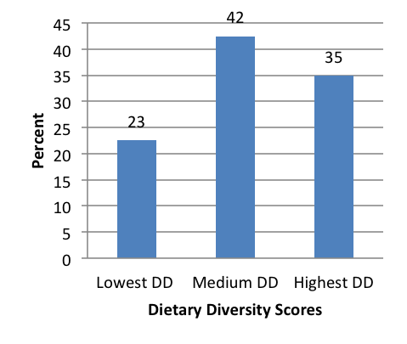

|  |
| --- |
| Nutrition and Anthropometry |

Acute malnutrition is predominant in the 36-47 months old children seconded by about 13 per cent within the 6 to eleven months old in the livelihood zone (Figure 11). About nine percent and six per cent of under-five children were moderately and severely malnourished, respectively in the livelihood zone. The results indicate that there were no severe or moderately malnourished children within zero to five months old children in the livelihood zone.

Figure 12: Prevalence of severe and moderate stunting by age grouping

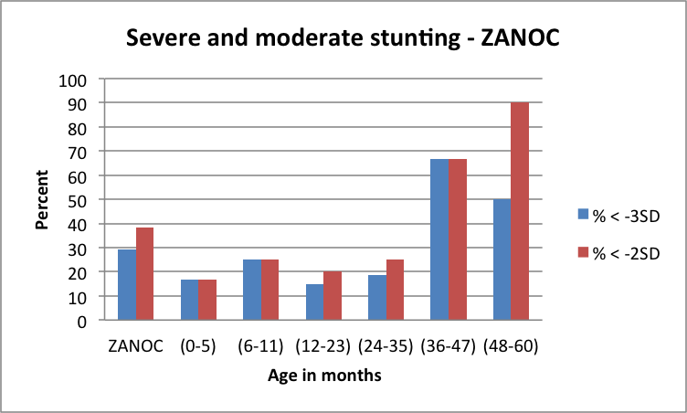

Figure 11: Prevalence of severe and moderate acute malnutrition by age grouping

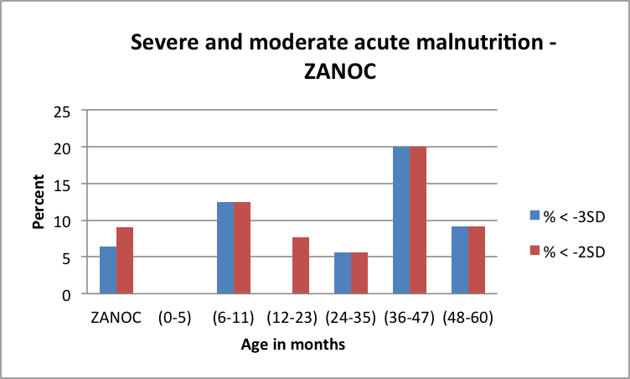

The prevalence of severe and moderate stunting is 29 per cent and 39 per cent, respectively in the livelihood zone (Figure 12). There is a high prevalence of severe and moderate stunting among under-five children within 48 to 60 months of age seconded by children who were 36 to 47 months old. The trend of moderate and severe stunting is mixed between zero months and 35 months old among under-five children in the livelihood zone.

The prevalence of severe and moderate stunting is 29 per cent and 39 per cent, respectively in the livelihood zone (Figure 12). There is a high prevalence of severe and moderate stunting among under-five children within 48 to 60 months of age seconded by children who were 36 to 47 months old. The trend of moderate and severe stunting is mixed between zero months and 35 months old among under-five children in the livelihood zone.

Figure 13: Prevalence of severe and moderate underweight by age grouping

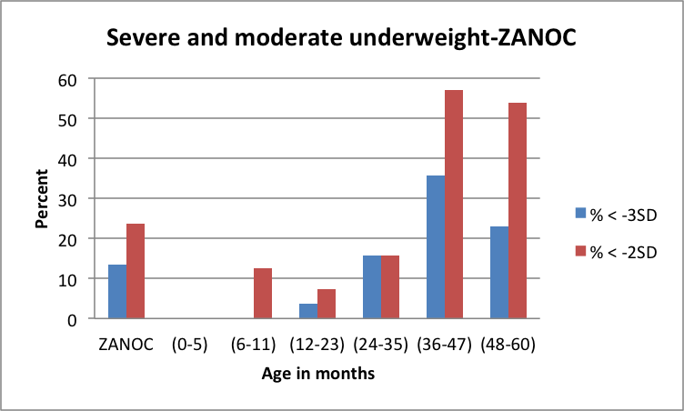

|  |
| --- |
| Conclusions and Recommendations |

As already mentioned, food and cash income from livestock products is low for the numbers of animals present. To increase production, herds would need more and better management, an investment that would need to be justified through better returns. These returns could be increased by, for example, support to dairy marketing and greater provision of services and infrastructure to encourage production. Crop farming yields could be improved but given the vagaries of rainfall it would require heavy investment in irrigation and extra water supplies to have real impact—so the focus should be on livestock productivity. This will most likely only initially benefit the wealthiest ('middle' and 'better off') households directly, but it will create additional new possibilities for poorer households through increased work opportunities. For many 'poor' and 'very poor' households, grants will remain the main source of income for some time to come.